Transport and Mobility Forum Agenda
Time & Date: Thursday 15th February 2023, 2 – 3:30 pm
Where: The DAAC, 4 Waldegrave Road, Teddington, TW11 8HT
Chair: Mary Harrison
Note taker: Hallie Banish

No. | Agenda Item | Actions
2:00 | Welcome and Introductions  Reminder about Palantypist, Heather who is joining us via Zoom  In attendance:  - Mary Harrison (Chair)  - Hallie Banish (notetaker)  - Heather Casali (palantypist via Zoom)  - Michael Aldington (SW Railways via Zoom)  - Matthew Howie (RATP Dev)  - Cllr Andy Hale  - Jamie  - Gareth  - Bea  - Paul  - Sue  - Yvonne  Apologies from: Sam Greening (TfL), James Pickard (TfL), Samantha Teggart (Abellio), Amanda Winterburn, Victoria Nurse, Scotty McLeod
2:10 | Actions from previous minutes:  - Mike to share numbers for passengers’ assistance with the group info about WhatsApp support – this is only available for SW Railways trains  Passenger Assistance numbers:  - Pre-booked: 24/7 number: 0800 52 82 100. There is a text relay number: 18001 0800 52 82 100  - WhatsApp for Assisted Boarding Points, a Turn Up and Go service if you have time to make contact last minute. WhatsApp and telephone number: 0800 528 6599. There is a video on this webpage with more information on the service: https://www.southwesternrailway.com/travelling-with-us/assisted-travel/assisted-boarding-points  - More information is available on this web page: https://www.southwesternrailway.com/travelling-with-us/assisted-travel  - Forum members to share their views on how they buy tickets and what staff priorities should be  - Forum members to feedback to the forum about specific crossings that are problematic  - Hallie to ask Sam what crossing timings at Manor Circus are based on  - Hallie to email Sam and arrange a few options for crossing trial with the group | Done  Ongoing  Ongoing  Ongoing  Ongoing
2:20 | Updates from the Chair  Recruitment of a new co-chair for the Richmond Transport & Mobility Forum – a JD and Person Spec are going to be created so we can recruit the right person to take on the role | Action: Mary to share the Job Description and Person Spec with the group once finalised
2:30 | Updates from Partners  SW Railways  WhatsApp and assisted point service – turn up and go travel (within the next 30-60 mins) requires 5-10 minutes notice – message gets sent to guard at the train or the staff on the station  There are holes in the system – they haven’t worked out how to get visually impaired people to the right area. Recommended for use at an unstaffed station so the guard can support.  Passenger assistance still exists, which requires 2 hours or more notice.  Question: Where would it be helpful for station staff to be? And what are their roles.  Jamie: Waitrose style service – continuity and consistency. People on the gate line, regularly open ticket office.  Ticket machines are not accessible and this is one of the things taken on board by the industry – will there be a new generation of TVMs? To be determined.  Mike knows there is a push to have more TfL style point to point tap in, tap out journeys. There won’t be a penalty between the smart ticket price and the paper ticket price.  There are a lot of unknowns in the ticketing world.  Paul: son who is a wheelchair user relies on ticket office. Recently when the ticket office was closed, guy on the gate couldn’t get the ticket machine to work and was told he couldn’t buy a ticket until after 12 pm  A level boarding study has been requested between Windsor, but hasn’t been approved. Mike is pushing for this.  Station Updates:  - Teddington – No formal opening date announced yet by Network Rail. It should be late Spring 2024. The lifts are being installed on the existing, Edwardian footbridge, so things will be in-keeping with the conservation in the area  - Barnes – No formal opening date announced yet by Network Rail. Suspect it will be later in the Summer/Autumn of 2024. For clarity, Barnes’ new footbridge with lifts, which will be roughly in the middle of the platform at the end of where the current canopy cover is, won’t have a roof on the footbridge.  - Isleworth – this should be opened in March 2024 with the new lifts. The lifts will come up from street level onto the platform, with the step-free interchange using the existing pedestrian subway which runs underneath the station (the station and railway are built up on a viaduct/embankment).  - Wandsworth Town – No formal opening date announced yet by Network Rail. The railway works have been delayed by the new development next to the station.  - During the next 12 months, the following stations on the SWR network will have step-free access:  - Walton-on-Thames  - Isleworth  - Stoneleigh  - Motspur Park  - Wandsworth Town  - Barnes  - Surbiton – lift on the carpark side of the station will be re-opened (Southside of the station)  Challenges with the reliability of the lifts at Whitton station – lifts were reported out of use, then they sent people to support and they were working. Issue with rock salt getting in the grooves and the doors can’t close. Oil being cold is also another issue. Network rail manage the lift.  Whitton lifts:  We believe some of the fault reports came from grit being caught in the door runners. During the winter, we put down a sort of rock salt onto the platforms to stop ice build-up and to prevent people slipping. However, as people walk along the platforms, they of course pick up some of this grit in their shoes and it gets kicked and deposited into the door runners of the lift, which then prevents the doors from closing. We made a few calls to Stannah and Network Rail who maintain our lifts, and upon arrival, there was no fault found so we think this has played a not-so-insignificant part in the poorer reliability of the lifts over the last 4-6 weeks with the cold weather.  TfL (read out in Sam’s absence)  Essential works at the A316 Manor Circus junction started in August. The works are split into two phases: urgent repairs to the bridge deck beneath the junction, and highway improvements to improve road safety.  The works on the bridge deck will be completed in the next few weeks – there has been a delay to completing this phase due to accidental damage to a water main beneath the junction in November, which needed to carefully replaced by Thames Water. Thames Water finished these works on Saturday (10th February). Over the coming weeks, our works contractors will complete the bridge deck repairs and remaining footway upgrades on the bridge deck.  After the bridge deck repairs have been completed, the second phase of the roadworks will begin, involving further footway upgrades around the junction, installation of the new pedestrian crossings, and reinstatement of the central roundabout feature, including new low-maintenance biodiverse planting, and tree planting.  The touchless push-button trial on the temporary crossings is fully functional, and we are hoping to run a series of site visits with interested stakeholders, including RUILS members, in the spring, when the weather improves and the majority of the roadworks have been completed. As a reminder, this trial allows people to activate the pedestrian crossing, using a handheld Bluetooth device or a mobile phone app. If anybody is interested in participating, please do get in touch with me (Sam!). samgreening@tfl.gov.uk  We continue to work with our permanent signals contractors to trial a similar touchless solution on the new, permanent crossings that will be installed at the end of the roadworks, later in the spring. The second trial will not require people to carry a Bluetooth button or mobile app, so we hope to understand how different users will experience the new solution. We will be able to share more information on this in the May meeting.  Question: When will the R68 going to be extended again?  Question: When will we go to Manor Circus as a group to test the temporary crossing?  RATP Dev  - Discussion on the location of Abellio vs RATP  Exerus, an AI piece of tech that learns people’s faces and can tell if a driver is falling asleep, looking a phones, etc. is being trialled. If a driver closes their eyes for 1.5 secs it logs it. Hoping this prevents accidents.  Only noticeable to the driver, vibration pad under the seat wakes/alerts the driver.  2-minute window – event happens, footage sent to call centre, then to control room, then to controller, then they contact the driver and ask them to pull over  Most of the time incidents can be prevented 30 minutes before  87/500 buses have this installed and could be built into tender for future.  There was a significant incident in Nov, a bus hit a pedestrian and there was another example of a bus going into a police car yesterday and 6 people injured  Across all of the electric vehicle routes (5) out of Fulwell  Question: Has there been good cooperation from the union?  Currently in ghost mode to collect data, what is the average…then phase 2 is vibration pack, phase 3 fully live with data going back and forth. There is some resistance but ultimately this is about saving lives not monitoring all actions of drivers.  If a sleeping event happens, the won’t just discipline the driver – they will interview and look at lifestyle, shift pattern, their lives, supporting them to not have it happen again  Data is being stored on a dashboard and logged in categories.  Question: Is there currently alcohol and drugs testing (yes, 10% of workforce is randomly tested each year)  RATP have been doing sessions with guide dogs uk – helping train them to use buses and get used to sights and sounds  Lost 3 routes, 465, S3, 481 – lost them to Abellio I think  Jamie – Are there things being done to prevent fires in electric vehicles?  HAVOC system can turn off the heating in electric vehicles, heat could be a cause of fires and over heating. They have put risk assessments in place to put buses in isolation so there isn’t a chain reaction – wind and fire brigade have created blankets to throw over the buses  There have been no updates from TfL about new ramps  Feedback about the loop systems on buses and getting interference. They don’t always work.  Possible Access Day with RATP at the depot. They could get a double decker with the sleep tech on it to show what has been done. | Action: Hallie to send questions to Sam  Action: Hallie to follow up with Matt about this to explore dates.
2:50 | Other updates  - Manor Circus TfL Accessible Crossing Trial  Question: when would people like to schedule a group test? March or April 2024? May is a good time but a note also made about wanting to do it sooner.  - Access Day at Abellio Bus Depot Twickenham  Samantha unable to attend this meeting, but said she would get back to us with potential dates. | Action: Hallie to follow up with Sam from TfL and Sam from Abellio
3:20 | Any Other Business  Quality of the roads between Teddington and Kingston – cycle route disappears – you get impatient bus drivers  Barnes station update – no opening date confirmed (likely autumn) – new footbridge with lifts are being put in per Sam’s update. Cllr Hale said that there has been work done by himself and others to better accommodate better for wheelchairs around the station – there hasn’t been through thought – the station is accessible but the areas surrounding are not.  New Changing Places toilet opened at Clapham Junction station, inside the Brighton Yard entrance on St John’s Hill.  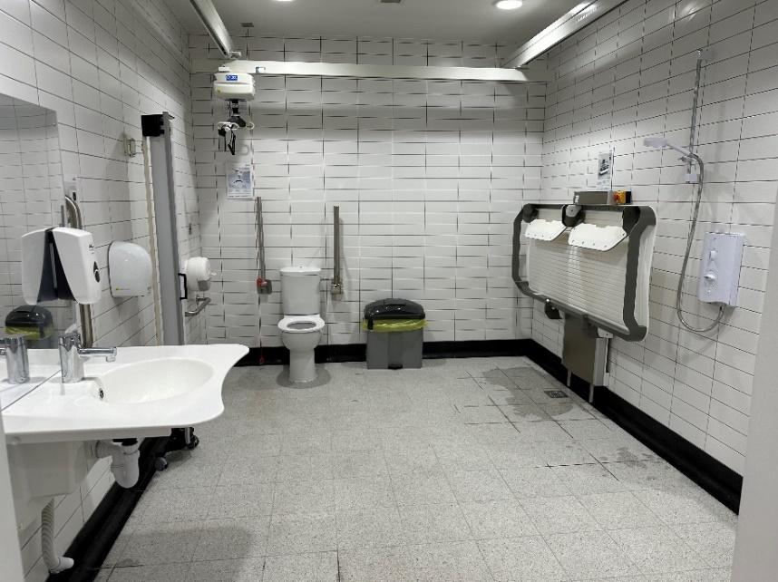  Image of the new changing places toilet, with hoist, shower, and other additional features. | Action: Cllr Hale to speak with Mary and Hallie to see how we as a group can support this work.

Upcoming Meetings
All meeting take place at the Ruils Office
- Thursday 23 May from 2:00 - 3:30 pm
- Thursday 12 September from 2:00 - 3:30 pm
- Thursday 21 November from 2:00 - 3:30 pm

